YOU WANT CHIPS WITH THAT?

Have you got what it takes to cook up a winner at the casino?
Have you got enough salt to play like a well-seasoned pro?
Do you know the difference between a roulette and a roulade?

This week, we’re serving up a generous portion of tasty tips and garnishing it with a side order of appetizing advice. All accompanied with a delicious smorgasbord of sensible suggestions.

- Don’t Overindulge

Know your limits. Make sure you don’t overindulge at the casino and end up struggling to pay the bill. It’s very important to stay on top of your finances and only risk what you can afford to lose. It’s all about having a little fun, testing your luck, and – hopefully – walking away a winner.

Remember: if Lady Luck ain’t showing you any love, don’t chase her. Come back and try again another day. Online casinos want you to have fun and return for second helpings. Don’t end up overdoing it and reaching for the Rennies.

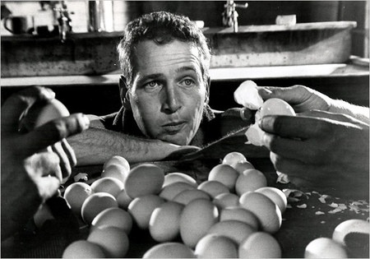

- Make Sure Your Casino is Michelin Starred

If you are looking at an online casino that accepts only wire payments, is not licensed by the Gambling Commission, and has offices in outer Mongolia, there is a very good chance this is a rogue operation. All this venue promises to serve up is a portion of pain, accompanied with a side of anguish.

The Gambling Commission is a great place to vet any casino. It was set up in 2005 specifically to regulate commercial gambling in the UK. It’s the Trip Advisor of the online gambling world. Any reputable online casino will carry the Gambling Commission logo. You can also check them all on the Gambling Commission website. If they have ever been censured, you will find the information here.

- Try The Specials: Grab That Bonus

Everyone loves a great specials board: a tempting array of the head chef’s exclusive creations, designed to drag hungry punters in from the street. Online casinos are the same. They want you to choose their venue for a little blackjack, roulette, or slots action. To persuade you to dive in, most of them offer exclusive bonuses and special deals.

If you are making your first real money deposit or just reloading that account balance, online casinos are only to happy to offer you a generous welcome or reload bonus. In a street packed with restaurants, it pays to shop around to find the tastiest deal on the block.

- Befriend the Maitre D’ – Become a VIP

If you want the best seat in the house and a sommelier who knows exactly what you are drinking, you will need to be a regular patron. Online casinos reward loyalty with a wide range of rewarding schemes. Some offer cash back. Other show how much they appreciate your business with free gifts, exclusive trips, and unique experiences.

Once again: shop around. VIP schemes vary from casino to casino. If you are a serious player, you can even try to negotiate a deal that is tailored exclusively for you. Get to know the front of house and you will never need to make a reservation again.

- Stick to the Menu: Strategy Pays

There are scores of different games to enjoy at the casino. Some, like roulette and the slots, rely on nothing but luck. You make your bet, spin the wheels, and hope for the best. Other games, however, are worth taking the time to get to know

Games like online blackjack and craps both have ‘best practice’ strategies that will help you maximize any potential return. At the end of the day, you still need the dice and cards to fall in your favour but good strategy will help you optimize your win. Use it.

- Skip the Wine Flight – Don’t Play Drunk

Everyone loves a drink from time to time but letting loose at the casino, after you have had a skinful, is never a good idea. Strategy will go out the window and there’s a serious risk of getting carried away. If you’re enjoying a little action at the tables, avoid the alcohol.

- Don’t Be Greedy

Why spoil a perfectly good meal by cramming down a desert.

There’s a reason why casinos like to keep you playing. As a certain Mr. Rogers once said: ‘You've got to know when to hold 'em, know when to fold 'em, Know when to walk away.’ If you are lucky enough to be ahead, it’s time to quit and run. If you’re ahead – head home!

